IN

-

CONFIDENCE

•

Organised, efficient and productive, autonomous / Independent.



**Position Description**

Senior Test Engineer

# Our purpose

Our long-term aspirations are to develop more long-term value-based relationships with our customers, and for our people to grow and develop so that they are better off working at the Cooperative.

# Our values

Our values represent who we are, how we think, and how we behave to bring these to life every day. You’ll demonstrate behaviours that define our core values and support an inclusive culture with a strong teamwork spirit.

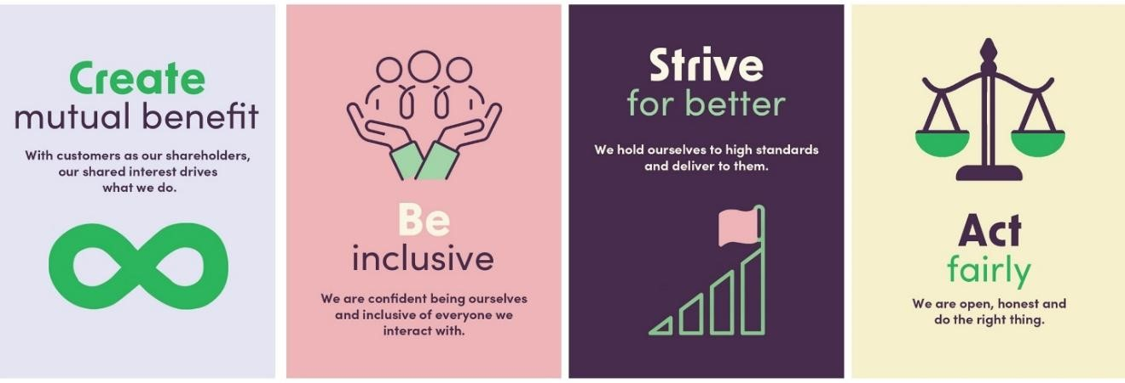

# About the team

# The Development, Testing and Security team is responsible for aligning the Solution Architecture design and development to meet the Bank’s business needs, as well as leading and managing the Banks overall security standards and practices as they apply to the Technology landscape.

# Purpose of this position

The purpose of this position is to provide timely and relevant information about quality in order to facilitate business critical decision making e.g. go live yes/no. You’ll work within your squad, using your understanding of the relevant product’s features and design to help support effective decision making.

Ideally, we are looking for someone with technical testing experience, and a willingness to continually improve our processes and practices. The role may require you to test Web applications, Mobile Apps and APIs as part of core banking replacement.

The position is part of a Testing Practice within the Bank, and we expect that our test team, together with the wider Digital and IT team, be better able to meet our business’s requirements for continuous and rapid iteration of our software. This will in turn lead to greater customer satisfaction and uptake of the Bank’s products and services.

**Position reports to: Lead Quality Engineer**

# Challenges and opportunities of this role

* **Core Banking Simplification -** We are invested in simplifying our core systems by transitioning features to modern platforms.
* **Creating Great Customer Experiences -** Our online presence is constantly evolving. Delivering beautiful and frictionless experiences to our customers and staff in every delivery. The underlying platforms that support the user experiences must be flexible and reliable.
* **Innovation -** Constantly challenging the status quo and bring fresh ideas into delivery to generate new ways of delivering services for the customer**.**

**How you will contribute:**

|  |  |
| --- | --- |
| **What you’ll do** | **Success will mean** |
| **Test Preparation** |  |
| * Continually prepare the necessary test approach, scenarios and data for our backlog of work in collaboration with the Business Analysts (BAs) and Developers. * Designing, developing, and maintaining automated test scripts to validate software functionality and performance. * Design, develop, and maintain robust automated test scripts for RESTful and gRPC APIs using tools like Postman, C# and similar. * Identify impact and dependencies on other systems and teams, other project risks and discuss with the relevant people. * Define and assist teams in creating test strategies across projects and proactively confirm scope of testing required. | Rigorous preparation of tests and identification of dependencies should result in successful and seamless deliveries to production. |
| Test Execution |  |
| * Testing by scripted and/or unscripted exploratory testing based on the need. * Ensuring overall application stability and functionality before each release by regression testing using Automated scripts or by running manual scripts. * Finding relevant test data from databases and APIs using SQL and Postman. * Continuously monitoring and improving the effectiveness of automated tests. * Use tools like Swagger, Postman or similar for manual verification and script generation. * Participate in code reviews and contribute to best practices in test automation and software quality assurance. * Ensuring testing aligns with CI/CD pipelines for rapid and reliable software delivery. * Monitor and review bug fixes and track issues through development, re-testing and closure and ensure timely and pragmatic decisions are made. * Monitor and improve test reliability, test execution speed, and reporting capabilities. * Continuously exploring our applications and platforms to expose vulnerabilities beyond the business requirements. * Query logs using AWS CloudWatch and provide relevant findings to developers to trace issues quick. | All tests for new functionality and regression are executed.  All issues and any blocked items are triaged with the team(s).  Zero change inflicted production issues due to insufficient test coverage.  Automation Test Suites maintenance.  . |

|  |  |
| --- | --- |
| **What you’ll do** | **Success will mean** |
| **Test Reporting** |  |
| * Measuring, reporting and communicating test results (e.g. what you’ve tested, not tested and what you’ve found) and progress to all relevant parties and stakeholders. * Maintain and update test documentation, test cases, and test data for testing.   This will be via direct face to face conversations with the team members, with the entire team in stand-up meetings also via automated routes. | Timely, accurate and relevant information about product quality is shared clearly and concisely to enable the team to:   * understand what has been tested and how * understand any issues * decide on the appropriate action e.g. fix. |
| Data policies & standards are adhered to (including data privacy & security policies & standards).  Business rules & guidelines are applied consistently.  High standards applied to the development, delivery and on-going management of data dictionaries & catalogues and master data management.  Support the Engineers to test & productionise code. | * Delivery of quality data products that meet the needs of the Bank. * Relentless pursuit of quality standards & ownership of solutions. |
| **Postproduction Release Verification** |  |
| * Ensuring overall application stability and functionality before each release by regression testing using manual scripts or by running relevant automated regression suites. * You will manage and maintain release and PIV checklists. * Verify post a production release that all batch changes released reconcile to the planned implementation and timing. | Follow-through of checks is imperative to a sound environment. This is also a requirement of internal and external audit and compliance.  Knowing of issues early allows for speedy backout of incorrect changes. |
| **What you’ll do** | **Success will mean** |
| **Learn and Improve** |  |
| * Continually learn the Bank’s products and services and the way they are processed in our IT systems. Help others to learn from your knowledge. * Bring improvements to how we develop software e.g. via implementing Agile practices and test automation. * Continue your own personal development e.g. keep current with new technologies and ways of working. * Understand the system architecture, release and environment management processes, and contribute towards quality initiatives and overall process improvements.   . | Ability to test a wider range of the functionality within our IT systems.  Demonstrable improvement in how we develop software e.g. increased coverage and reduced time to test from test automation.  Demonstrable improvement in your own capabilities. |
| **Other Accountabilities** |  |
| * Works collaboratively with other members of the Team. * Collaborate strongly with Practice Leads on strategy, planning, and improvements and help in formulating and implementing standards for the Testing practice. * Be a leader and mentor to all testers, build awareness for quality and drive initiatives to build quality into our processes. * Complies with Health & Safety requirements, including practicing safe work methods, and helping management eliminate workplace hazards. | Team work is well-integrated and team goals are achieved.  Demonstration of behaviors that define our core beliefs  H&S good practice and compliance supports a safe workplace. |

# Decision making and responsibilities

**a) Decisions and/or financial accountabilities:**

• N/a

**b) Actions and decisions that are recommended to a higher level of management for approval:**

* Testing Strategies, techniques and tools
* Training requirements

# Qualifications and experience

* 5+ years of working experience in contributing to strong QA outcomes across web, mobile, system applications and integration.
* Strong hands-on experience with C# automation frameworks,CI/CD, test-driven development and testing technologies.
* Ability to mentor and guide the squad, helping to implement best practices and testing methodologies across the squads.
* Passion for driving results while working closely with cross-functional teams to ensure high-quality delivery at every stage.
* Background testing within mobile / device testing teams especially Apple/IOS, Android or both.
* Experience to lead defect triage and produce test report.
* Strong Experience using API tools such as Postman & Swagger to test web services, Rest APIs and gRPC APIs.
* Solid understanding of data management (i.e. data preparation and validation) and experience using SQL for either data preparation or general querying.
* Comfortable liaising with 3rd parties in order to test your systems with theirs.
* Be a quality champion, share your knowledge, coach others in analysts and quality engineering practices.
* A keen desire to grow and develop in a fast-paced environment, with a focus on continual learning and improvement.
* Experience of working in an Agile team and proven experience in Devops, Continuous Delivery.
* Experience using Git to manage test automation code.

.

# Skills and attributes

## Technical Skills

* Excellent analytical, logical thinking ability, with a focus on detail.
* API tools such as Postman & Swagger to test web services and Rest APIs and gRPC APIs
* Web Automations tools using tools like Playwright, Cypress and similar using C#.
* API automation libraries like RestSharp, Flurl or RestAssured.
* Solid understanding of SQL.

## Leadership Skills

You will be expected to demonstrate behaviours from our Leadership skills framework through your actions, the way you work and how you work with others.

## Personal Attributes

* Values based – demonstrates personal commitment to the established values of The Co-operative Bank.
* Focus on results – takes personal responsibility for achieving results.
* Inquisitive and Probing – ask questions and obtains absolute satisfaction from the answers given ensuring no unpleasant surprises or mistakes from missed information.
* A passion to learn and develop new skills – self learning is key.
* Self-management – has a structured and pro-active “can do” approach and plans, organizes and prioritizes work effectively to achieve required outputs.
* Judgement – knows when to escalate issues.

## Conceptual Skills

* Actively looks to collaborate with others, using effective communication skills.
* Actively seeks to understand business priorities & the resulting implications for IT.
* Provides full transparency on your work.
* Develop and maintain standard QA and Test documents to form an integral part of the delivery methodology.
* Understand the system architecture, release and environment management and contribute towards quality initiatives and overall process improvements.

## 